Course Level Project Report

**IOT-SENSORS AND DEVICES**

**(211ECE1400)**

|  |  |
| --- | --- |
| **Team Number** | 11 |
| **Project Title** | Intelligence braking system |
| **Team Members**  **(Reg. No & Name)** | S .Praneeth gowd |
| T .Santhosh kumar reddy |
| V .Sreenivasulu |
| Y .Gopi krishna |
| D.Ganesh |
| **Faculty In Charge** | Charles pravin .J |

**Table of Contents**

|  |  |  |
| --- | --- | --- |
| **S. No.** | **Name of the Content** | **Page No** |
|  | Abstract |  |
|  | Introduction |  |
|  | Motivation |  |
|  | Objective of the project |  |
|  | General Block Diagram |  |
|  | Components used |  |
|  | Methodology |  |
|  | Prototype and Implementation |  |
|  | Conclusion |  |
|  | References |  |
|  | Appendix |  |
|  | Publication / Competition certificate (if any) |  |

**1.Abstract:**

The advancement of intelligent braking systems represents a milestone in automotive safety technology. This abstract delves into the design, functionality, and impact of these systems, shedding light on their critical role in ensuring vehicle and road safety.

Intelligent braking systems encompass a spectrum of technologies, including Anti-lock Braking Systems (ABS), Electronic Stability Control (ESC), Autonomous Emergency Braking (AEB), and Adaptive Cruise Control (ACC). These systems are designed to mitigate accidents, reduce braking distances, and enhance control, especially in emergency situations.

The abstract examines the intricate mechanisms and sensors employed in these systems, highlighting their ability to monitor road conditions, detect obstacles, and adapt braking force to prevent skidding or loss of control. Moreover, the integration of artificial intelligence and machine learning algorithms has augmented these systems, enabling predictive analysis and real-time decision-making capabilities.

Furthermore, the abstract addresses the significant impact of intelligent braking systems on reducing accidents and fatalities. Studies and statistical data showcasing the effectiveness of these systems in preventing collisions and minimizing the severity of accidents substantiate their vital role in ensuring road safety.

In addition to safety, the abstract discusses the ongoing evolution of these systems, exploring their integration with connected vehicle technology and the potential for collaborative communication between vehicles (V2V) and infrastructure (V2I), further enhancing their efficacy.

**2.Introduction:**

Driving is a common activity for most of the people. The number of vehicles is increasing day by day.Now a days, the technology has got vast changes which leads increase in speed. The speed plays avital role to maintain time for longer distances. But, this speed also getting a major problem for causes of road accidents. The common braking is not sufficient for avoidance of accidents when driver is not active. Further improvement has to done in braking system in order to brake a vehicle when driver is not able to brake i.e., it may needs automatic braking system. This automatic braking system allows the vehicle to brake without support of the driver. The main target of the ultrasonic braking system is that, vehicles should automatically brake when the sensors sense the obstacle. This is a technology for automobiles to sense an imminent forward collision with another vehicle or an obstacle, and to brake the vehicle accordingly, which is done bythe braking circuit. This system includes two ultrasonic sensors viz. Ultrasonic wave emitter and ultrasonic wave receiver. The ultrasonic wave emitter provided in front portion of an automatic braking system vehicle, producing and emitting ultrasonic waves in a predetermined distance in front of the vehicle. Ultrasonic wave receiver is also provided in front portion of the vehicle, receiving the reflected ultrasonic wave signal from the obstacle, the reflected wave (detection pulse) is measured to get the distance between vehicle and the obstacle. The DC gear motor is connected to the wheels of vehicle and power input is given to it from arduino board. Then PIC microcontroller is used to control the servo motor based on detection pulse information and the servo motor in turn automatically controls the braking of the vehicle, Thus, this new system is designed to solve the problem where drivers may not be able to brake manually exactly at the required time, but the vehicle can stop automatically by sensing the obstacles to avoid an accident.

In order to reduce the emission levels, more work is going on for the modification of engine work functions and all. There are several kinds of braking mechanism systems that would only can be applicable mechanically, to move the ideology more deep and brief the automatic braking system will be more sufficient and satisfactory in addition to mechanical braking system. In present generation, number of vehicles are coming into existence with newer technologies for implementation of human comfort and other conditioning. To extend the ideology in more brief manner and to take the step in different way, may automatic braking system would fulfill the methods of extension of technical existences.

**2.1.Motivation:**

The motivation behind the development and implementation of intelligent braking systems in vehicles stems from a core commitment to significantly enhance road safety, mitigate accidents, and save lives. Several key factors drive the motivation for these advanced braking technologies:

1. **Enhanced Safety:** The primary motivation is to create safer roadways. Intelligent braking systems aim to prevent accidents by significantly reducing braking distances, especially in emergency situations. By enabling faster and more precise reactions to road conditions and potential hazards, these systems greatly reduce the risk of collisions.
2. **Accident Prevention:** The ultimate goal is to prevent accidents and minimize their severity. By employing advanced sensors and technologies, these systems can detect and react to obstacles or hazards on the road, actively working to prevent collisions or reduce their impact.
3. **Human Error Mitigation:** Human error is a leading cause of accidents. Intelligent braking systems are designed to complement human drivers, providing an additional layer of safety by intervening in critical situations or compensating for delayed human reactions.
4. **Technological Advancements:** Advancements in sensor technology, artificial intelligence, and machine learning have made it possible to create more responsive and sophisticated braking systems. This technological progress fuels the motivation to develop and integrate these systems into vehicles.
5. **Legislative Requirements and Safety Standards:** Many regions have stringent safety regulations, mandating the inclusion of advanced safety features in vehicles. This requirement serves as a significant motivation for the automotive industry to innovate and implement intelligent braking systems.
6. **Consumer Demand for Safety:** As consumer awareness of vehicle safety increases, there's a growing demand for safer vehicles. The motivation for automakers to integrate intelligent braking systems is amplified by the market's preference for vehicles equipped with advanced safety features.
7. **Reduced Insurance Costs:** Improved safety features in vehicles can lead to reduced insurance costs for consumers, creating an additional incentive for both manufacturers and consumers to embrace these systems.
8. **Advancing Technology Integration:** Intelligent braking systems are not standalone; they are part of a larger trend of integrating technology into vehicles. They play a role in the overall development of connected and autonomous vehicles, shaping the future of transportation.

**2.2.Objective:**

• The objective of this project is to design the automatic braking system in order to avoid the accident.

• To develop a safety vehicle braking system using ultrasonic sensor and to design a vehicle with less human attention to the driving.

This project is necessary to be attached to every vehicle. Mainly it is used when drive the vehicles in night time. Mostly the accident occurred in the night time due to long travel the driver may get tired. So the driver may hit the front side vehicle or road side trees. By using this project the vehicle is stopped by automatic braking system. So we can avoid the accident.

The scope of this project is to develop an ultrasonic sensor to detect the obstacle and to process the output from the ultrasonic sensor to drive the servomotor as an actuator.

Vehicles can automatically brake due to obstacles when the sensor senses the obstacles. The focus of this project is designing an automatically braking system that can help us control the braking system of a vehicle.

The automatically braking system also needs to work with an ultrasonic sensor, which produce sound pulse by a buzzer. The ultrasonic wave is generated from a transmitter and sends to a receiver.

**Block diagram:**

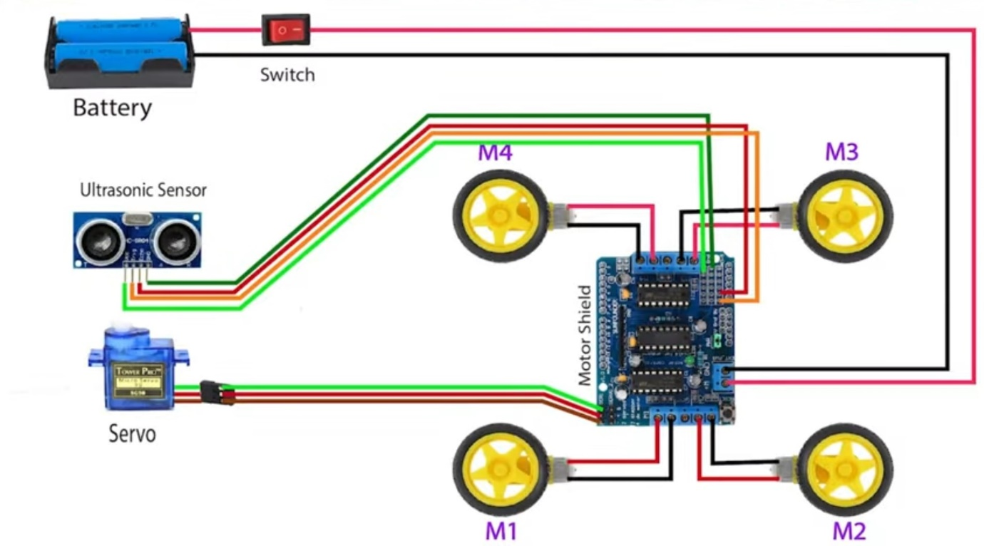

**3.1.Components:**

ULTRASONIC SENSOR:

Ultrasonic ranging and detecting devices use high-frequency sound waves to detect the presence of an object and its range. The systems either measure the echo reflection of the sound from objects or detect the interruption of the sound beam as the objects pass between the transmitter and receiver. An ultrasonic sensor typically utilizes a transducer that produces an electrical output in response to received ultrasonic energy. The normal frequency range for human hearing is 20 to 20,000Hz.

ULTRASONIC SENSING AND CONTROL:

Ultrasonic signals are like audible sound waves, except the frequencies are much higher. Our ultrasonic transducers have piezoelectric crystals which resonate to a desired frequency and convert electric energy into acoustic energy and vice versa. The illustration shows how sound waves, transmitted in the shape of a cone, are reflected from a target back to the transducer. An output signal is produced to perform some kind of indicating or control function. A minimum distance from the sensor is required to provide a time delay so that the ―echoes‖ can interrupt. Variables which can affect the operation of ultrasonic sensing include, target surface angle, reflective surface roughness or changes in temperature or humidity. The targets can have any kind of reflective form –even round objects.

DC MOTOR:

Geared DC motors can be defined as an extension of DC motor which already had its insight details demystified here. A geared DC Motor has a gear assembly attached to the motor. The speed of motor is counted in terms of rotations of the shaft per minute and is termed as RPM. The gear assembly helps in increasing the torque and reducing the speed. Using the correct combination of gears in a gear motor, its speed can be reduced to any desirable figure. This concept where gears reduce the speed of the vehicle but increase its torque is known as gear reduction. This insight will explore all the minor and major details that make the gear head and hence the working of geared DC motor. DC Gear motor is also called DC Geared Motor, Geared Dc Motor and gear head motor or gearbox motor. It consists of a electric DC motor and a gearbox or gear head; these gear heads are used to reduce the DC motor speed. While increase the DC motor torque. Therefore user can get lower speed and higher torque from gear motor.

Applications:

1) Home Appliance.

2) Office Automation.

3) Robotics: Robotics arm, cars. Robotic toy. Teaching Robotics etc.

4) Sanitary Automations: Preapproval Dispensers, Soap dispenser, Air Freshener Dispenser, Toilet Lid opener, Seat-Ganger, Sensor Sanitary Bin, Feminine Hygiene.

ARDUINO UNO R3:

Arduino is a software company, project, and user community that designs and manufactures computer open-source hardware, open-source software, and microcontroller-based kits for building digital devices and interactive objects that can sense and control physical devices. The project is based on microcontroller board designs, produced by several vendors, using various microcontrollers.

These systems provide sets of digital and Analog I/O pins that can interface to various expansion boards (termed shields) and other circuits. The boards feature serial communication interfaces, including Universal Serial Bus (USB) on some models, for loading programs from personal computers. For programming the microcontrollers, the arduino project provides an integrated development environment (IDE) based on a programming language named Processing, which also supports the languages C and C++.

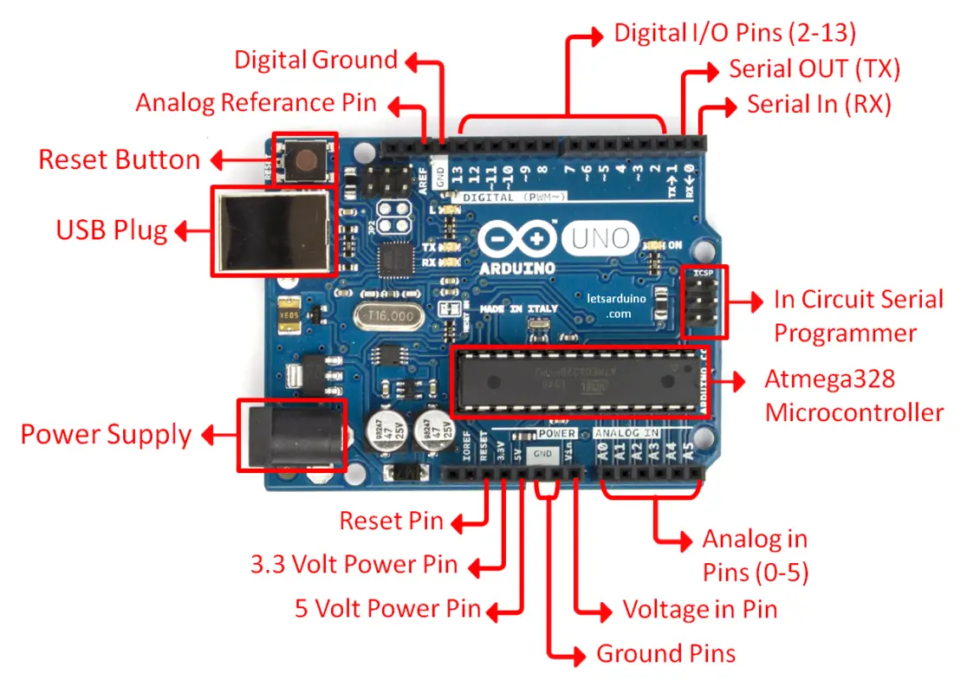

Ultrasonic sensors:

They are widely used in cars as parking sensors to aid the driver in reversing into parking spaces. They are being tested for a number of other automotive uses including ultrasonic people detection and assisting in autonomous UAV navigation.

Ultrasonic ranging module HC - SR()4 provides 2cm - non-contact measurement function, the ranging accuracy can reach to 3mm. The modules includes ultrasonic transmitters, receiver andcontrol circuit.

The basic principle of work:

1) Using 10 trigger for at least 1 high level signal,

2) The Module automatically sends eight 40 kHz and detect whether there is a pulse signal back.

3) IF the signal back, through high level, time of high output 10 duration is the time from sending ultrasonic to returning. Test distance = (high level time * velocity of sound (340M/S).

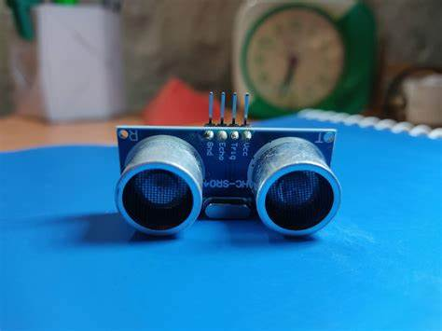

DC GEAR MOTOR:

DC geared motors are essentially a DC shunt motor which has been specially designed for low inertia, symmetrical rotation and smooth low-speed characteristics. Geared motor is a motor with a closed feedback system in which the position of the motor will be communicated back to the control circuit in the motors. Geared motors are formed from four different elements: a DC motor, a position-sensing device (a potentiometer), a gear reducing part and a control unit. All of these components work together to make the motor to accept control signals that represent the desired output of the motor shaft and power the DC motor until its shaft is turned to the right position. The shaft in geared motors doesn't rotate as freely as those in regular DC motors; it is only able to rotate around 200 degrees in both directions. The position sensing device in a geared motor determines the rotation of the shaft and thus the way the motor needs to turn in order to arrive at the desired position. The sliding mode control is robust to plant uncertainties and insensitive to external disturbances. It is commonly used to get good dynamic performance of controllable systems. Even then, the chattering phenomena due to the finite speed of the switching devices can affect the system behavior significantly. Besides, the sliding control needs the knowledge of mathematical model of the system with bounded uncertainties. Reduced chattering may be achieved without sacrificing robust performance by combining the attractive features of fuzzy control with SMC.

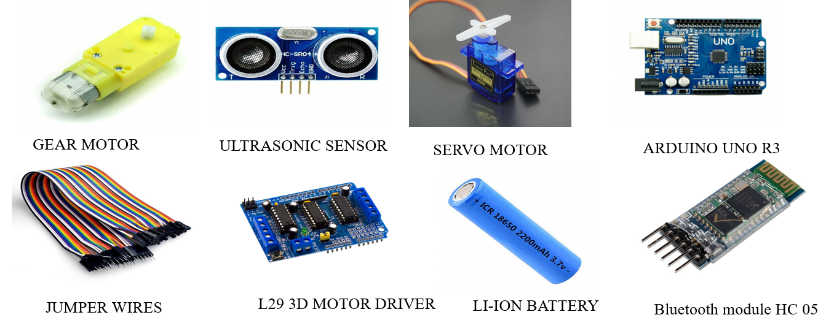

A servo motor is a specialized type of rotary or linear motor that operates based on a closed-loop control system. It is designed to accurately control the movement of an object or mechanical system by receiving and interpreting signals from an external source, typically a controller or a computer.

Key Components and Operation:

1. **Motor:** The servo motor itself consists of a motor, such as a DC motor or an AC motor, coupled with a feedback system that provides information about the motor's position or speed. This feedback mechanism typically includes an encoder, resolver, or potentiometer.
2. **Control System:** Servo motors operate using a closed-loop control system. This system continuously receives feedback from the motor's position, compares it to the desired position, and adjusts the motor's movement until it reaches the intended target.

Lithium-ion batteries (Li-ion) are rechargeable batteries known for their high energy density and have become the go-to power source for various electronic devices, from smartphones and laptops to electric vehicles. These batteries employ lithium ions to move back and forth between the positive and negative electrodes during charge and discharge cycles.

Key Components and Operation:

1. **Anode (Negative Electrode):** Typically made of carbon, the anode receives and stores lithium ions during the charging process.
2. **Cathode (Positive Electrode):** The cathode is composed of a lithium metal oxide, which receives the lithium ions when the battery is discharging.
3. **Electrolyte:** A separator in the form of an electrolyte, usually a lithium salt dissolved in an organic solvent, allows the movement of lithium ions between the anode and cathode. It is critical in preventing short circuits within the battery.
4. **Collector:** Both the anode and cathode have collectors (usually made of copper for the anode and aluminum for the cathode) that facilitate the flow of electricity.

**3.2.Methodology:**

The methodology for an "Intelligent Braking System" project involves a structured approach to design, develop, test, and implement a system aimed at enhancing vehicle safety. Below is a generalized outline of the methodology for such a project:

1. **Project Planning and Definition:**
   * Define project objectives: Determine the specific goals and expected outcomes of the intelligent braking system.
   * Establish project scope: Identify the parameters, limitations, and boundaries of the project.
   * Create a project plan: Develop a timeline, milestones, and resource allocation for the project.
2. **Research and Requirements Gathering:**
   * Conduct an in-depth study of existing braking systems, safety standards, and technological advancements in the field.
   * Gather functional and non-functional requirements for the intelligent braking system, considering factors such as speed, accuracy, response time, and safety standards.
3. **System Design:**
   * Develop system architecture: Create a detailed blueprint of the intelligent braking system, including the integration of sensors, control units, and actuators.
   * Define control algorithms and decision-making processes: Determine the logic for interpreting sensor data and making braking decisions.
   * Consider AI integration: Explore the incorporation of artificial intelligence for predictive analysis and decision-making.
4. **Prototype Development:**
   * Build a prototype: Develop a physical model or a software simulation of the intelligent braking system based on the design.
   * Integrate sensors and actuators: Install and test the sensors responsible for detecting obstacles or road conditions and the actuators for controlling braking.
5. **Testing and Validation:**
   * Conduct simulation tests: Employ simulated scenarios to test the system's performance in different road conditions and emergency situations.
   * Real-world testing: Implement the system in controlled real-world environments to evaluate its functionality and accuracy.
   * Validate against safety standards: Ensure the system meets industry safety standards and regulatory requirements.

**4.Prototype:**

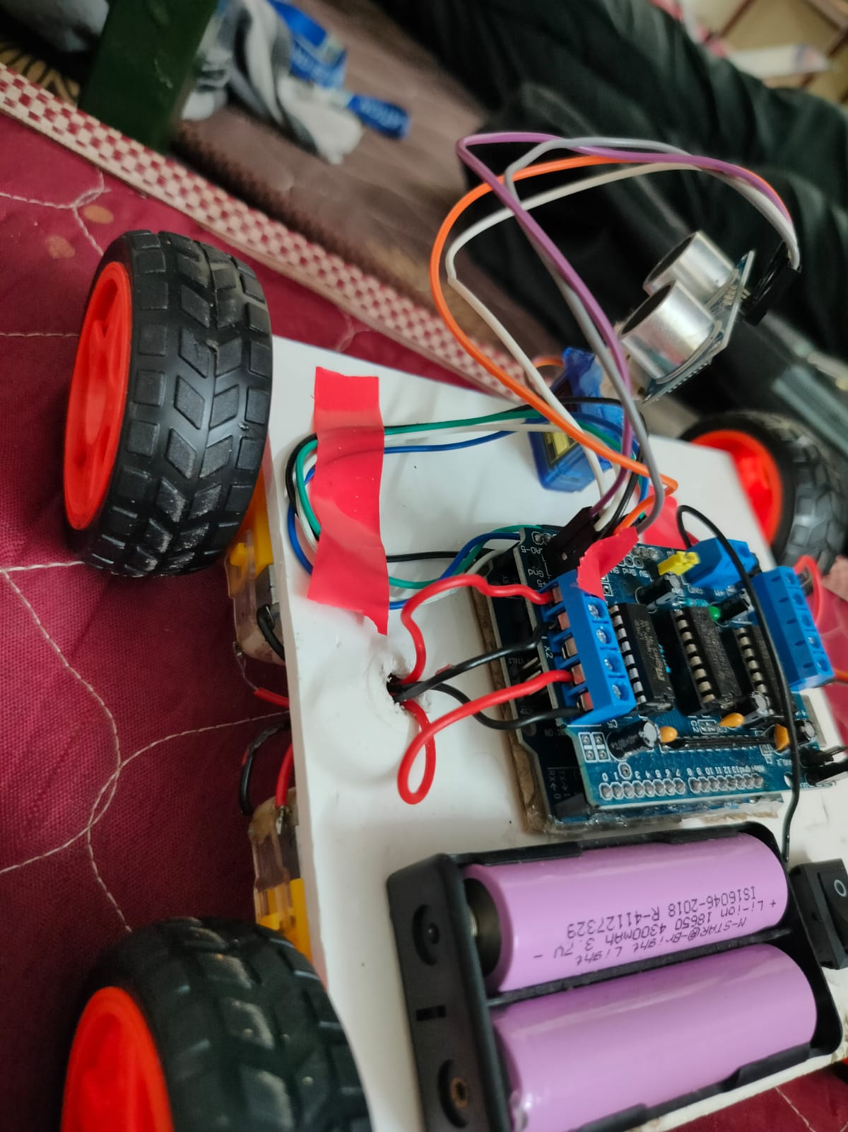

**Circuit diagram:**

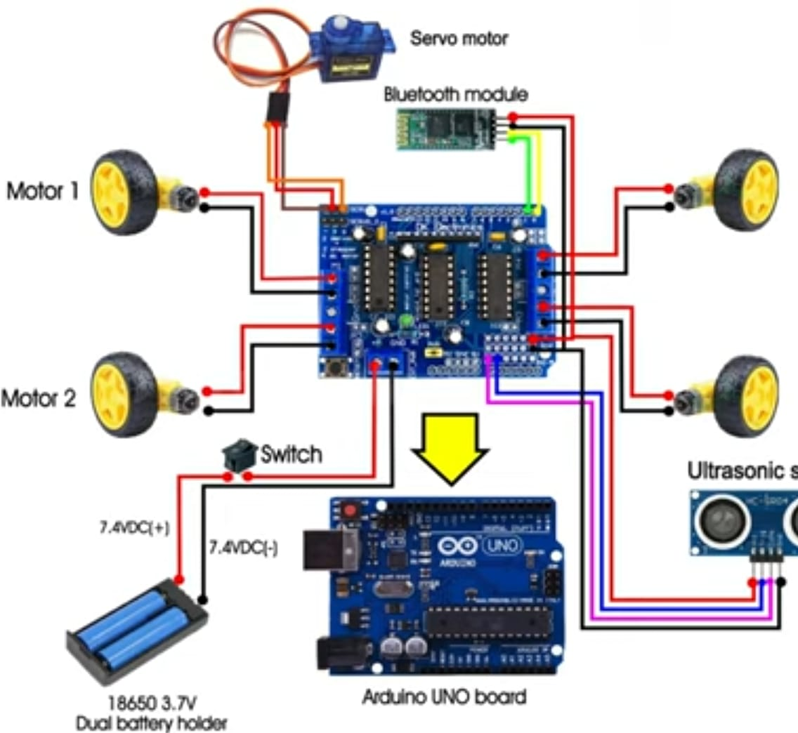

**5.Conclusion:**

We have successfully completed the fabrication of automatic braking system model prototype and this project presents the implementation of an Automatic Braking System for Forward Collision Avoidance, intended to use in vehicles where the drivers may not brake manually, but the speed of the vehicle can be reduced automatically due to the sensing of the obstacles. It reduces the accident levels and tends to save the lives of so many people. By doing this project practically we gained the knowledge about working of automatic braking system and with this future study and research, we hope to develop the system into an even more advanced speed control system for automobile safety, while realizing that this certainly requires tons of work and learning, like the programming and operation of microcontrollers and the automobile structure. Hence we believe that the incorporation of all components in Automatic Braking System will maximize safety and also give such system a bigger market space and a competitive edge in the market.

**6.References:**

[**https://youtu.be/aE_J7B-O4VQ?si=wAsM8U5saZy3vnrR**](https://youtu.be/aE_J7B-O4VQ?si=wAsM8U5saZy3vnrR)

[**https://bit.ly/3IhfCMc**](https://bit.ly/3IhfCMc)

[**https://bit.ly/3GWcmmD**](https://bit.ly/3GWcmmD)

**Appendix:**

**A: Technical Specifications**

1. **Braking System Components**
   * Detailed list of components used in the intelligent braking system, such as sensors, actuators, control units, etc.
2. **System Architecture**
   * Schematic diagrams or technical drawings illustrating the architecture of the intelligent braking system.
3. **Performance Metrics**
   * Tables or graphs showcasing the performance metrics of the system, such as response time, accuracy, and efficiency.

**B: Case Studies and Test Results**

1. **Real-world Test Scenarios**
   * Descriptions of different test scenarios where the intelligent braking system was implemented and results obtained.
2. **Comparison with Conventional Braking Systems**
   * Comparative data between the intelligent braking system and traditional braking systems in terms of effectiveness, safety, and performance.

**C: Regulatory Compliance and Standards**

1. **Compliance Details**
   * Information on how the intelligent braking system adheres to industry standards and regulations.
2. **Safety Certifications**
   * Details about safety certifications and standards met by the system.

**D: Cost Analysis**

1. **Implementation Costs**
   * Breakdown of costs involved in designing, implementing, and maintaining the intelligent braking system.
2. **Long-term Benefits**
   * Analysis of cost-saving or safety benefits resulting from the use of the intelligent braking system.